  - EXPERIMENT2.1:DATA SPLIT UP AND CROSS VALIDATION

Aim: To divide a dataset into training and testing sets and use cross-validation to evaluate the performance of a machine learning model accurately.

  - Algorithm:
Step 1: Import the required Python libraries, such as pandas and scikit-learn.

Step 2: Load the dataset into the program.

Step 3: Separate the input features (X) and the target output (y).

Step 4: Split the dataset into training and testing sets using train_test_split().

Step 5: Select a machine learning model.

Step 6: Apply cross-validation using cross_val_score() to evaluate the model.

Step 7: Calculate the average cross-validation score.

Step 8: Train the model using the training data.

Step 9: Test the model using the testing data.

Step 10: Display the model's performance and accuracy.

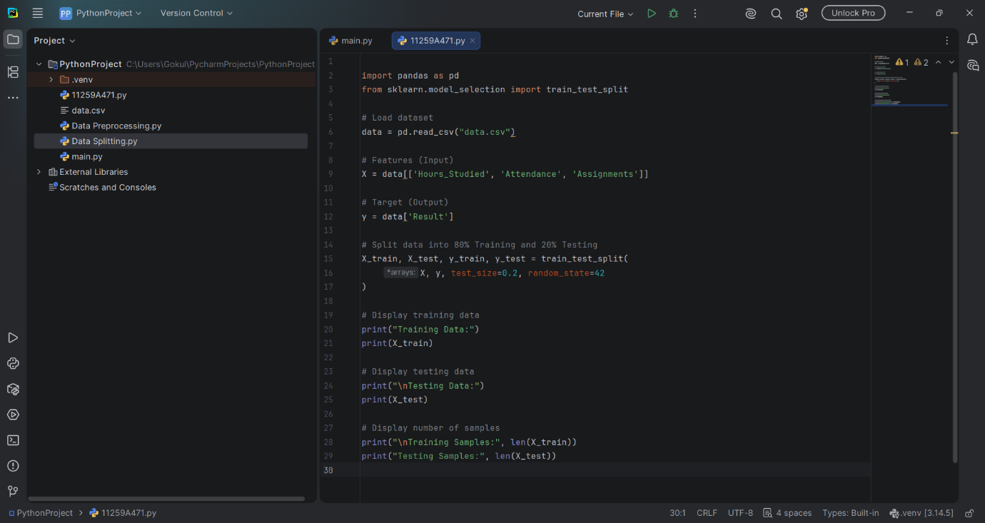

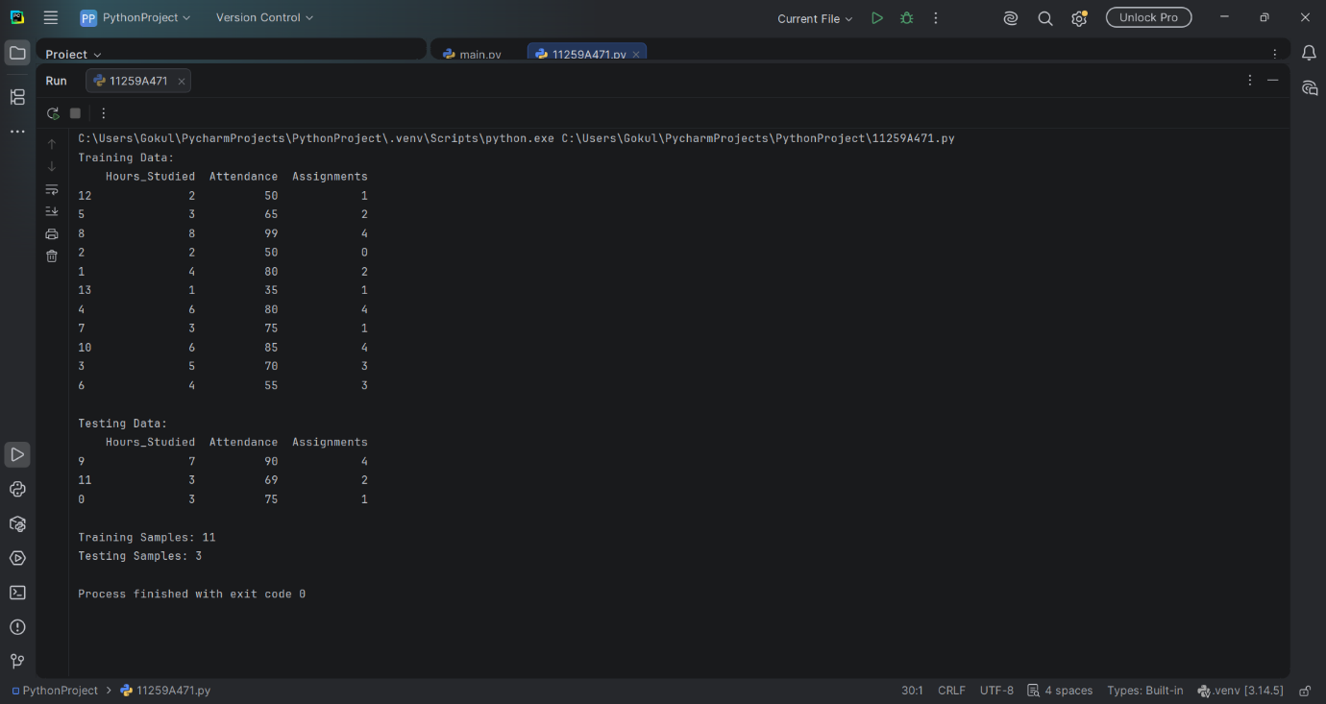

Result: The dataset is divided into training and testing sets, and cross-validation is used to evaluate the machine learning model's performance.

